Notice of Admission

Effect 01/01/2021 CMS is requiring agencies to submit a Home Health Notice of Admission (NOA) instead of a RAPs on and after 01/01/2021.
Per CMS guidelines (MLN Matters MM12256)
- HHA must submit a NOA to their MAC within 5 calendar days from the start of care date. The NOA is a one-time submission that establishes the HH POC and covers contiguous 30-day POCs until you discharge the individual from Medicare HH services
- NOA will be sent using Type of Bill (TOB) 32A, then TOB 329 will continue to be used for final claims. Cancellation of Admission will use TOB 32D.
  - Remarks are recommended when cancelling the NOA.
- NOAs can be submitted to your MAC by mail, Electronic Data Interchange (EDI) or Direct Data Entry (DDE).
- To submit an NOA, you mut have a verbal or written order from the physician that contains the services requires for the initial visit. You must have conducted an initial visit at the start of care (SOC)
- CMS only requires 1 NOA for any series of HH POCs beginning with admission to home care and ending with discharge. Once you report a discharge to Medicare, you must send a new NOA before you submit any additional claims.
- All patients receiving HH services in 2021 whose services will continue in 2022, agencies should submit a NOA with a one-time, artificial “admission” date corresponding with the “From” date of the first period of continuing care in 2022
- There will be a non-timely submission reduction in payment amount tied to any late NOA submissions when you don’t submit the NOA within 5 calendar days from the start of care. The reduction in payment would be equal to a 1/30th reduction to the wage adjusted, 30-day period payment amount for each day from the HH SOC date until the date you submit the NOA.
- If you fail to send the NOA timely, you may request an exception, which if approved waives the consequences of late filing. The 4 circumstances that may qualify for an exception are:
  - Fires, floods earthquakes, or other unusual events that inflict extensive damage to the HHA’s ability to operate.
  - An event that produces a data filing problem due to a CMS or MAC systems issue that is beyond your control.
  - You are a newly Medicare-certified HHA that is notified of that certification after the Medicare certification date, or which is awaiting its user ID from its MAC.
  - Other circumstances that CMS or your MAC determines to be beyond your control.
- Your MAC will not grant exceptions if:
  - You can correct the NOA without waiting for Medicare systems actions
  - You submit a partial NOA to fulfill the timely-filing requirement.
  - You have multiple provider identifiers and submit the identifier of a location that didn’t provide the service.
- Claims submitted before an NOA has been received for the beneficiary will be returned to provider.
Allegheny Software will be accommodating these changes by adding an additional screen within Billing. See below.

- NOA is located within the Billing Tab>Notice of Admission
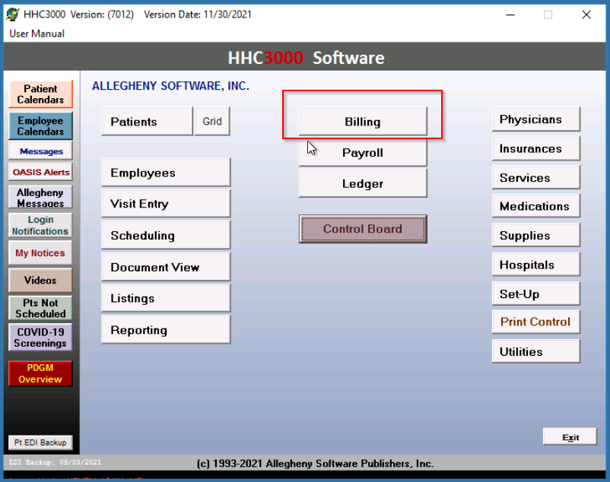
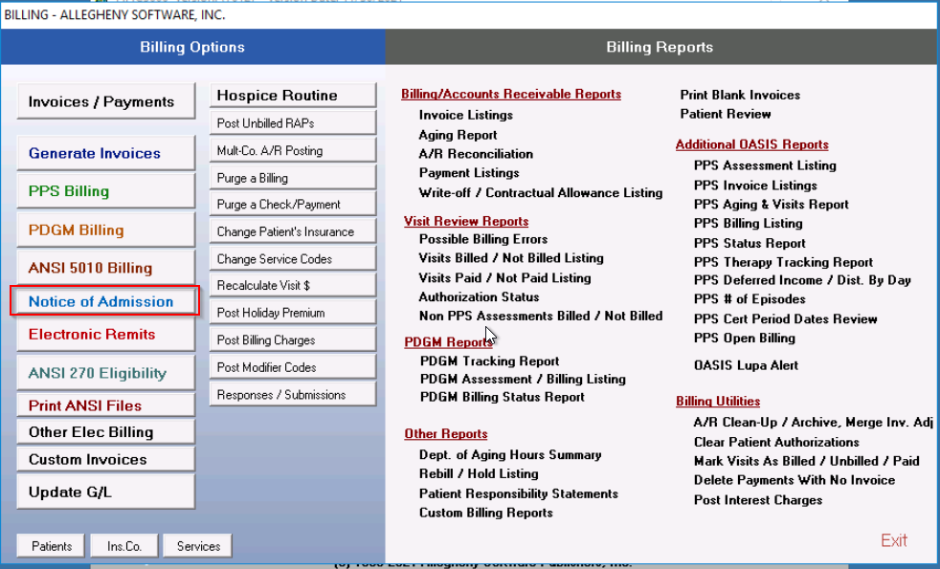

- Assessments that require NOA submissions will populate on the grid.
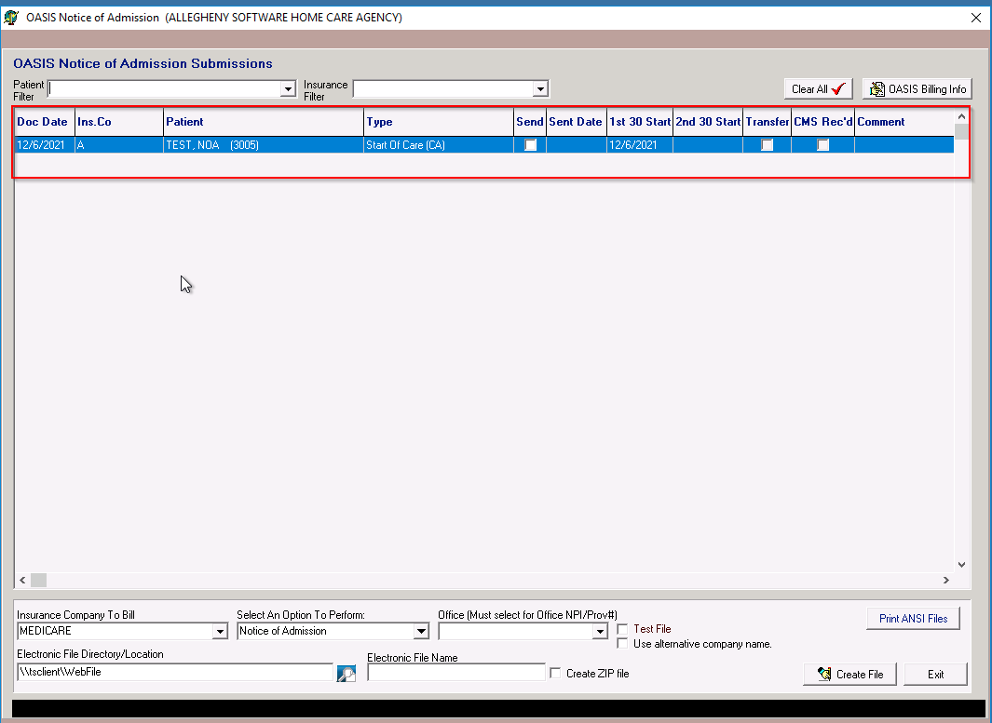
- User will select the desired assessment(s) by clicking in the checkbox in the “Send” column, select an “Option to Perform” and create an “Electronic File Name”
The software will populate the sent date after the file is created.
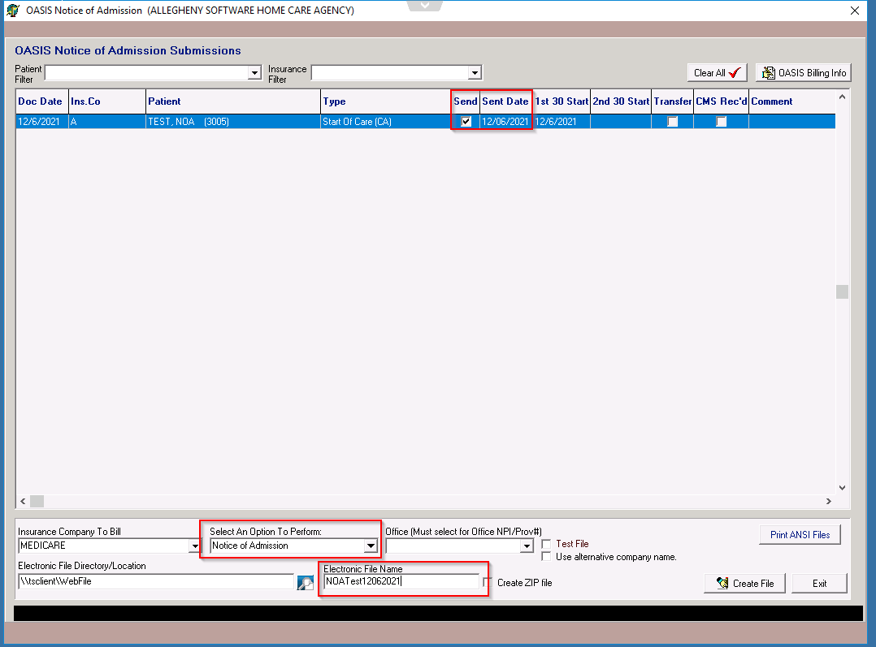
- To enter the date the NOA was received/accepted by CMS, the user will select the “OASIS Billing Info” button and select the checkbox by “CMS received NOA”
The user may add comments in the “Remarks” field if desired
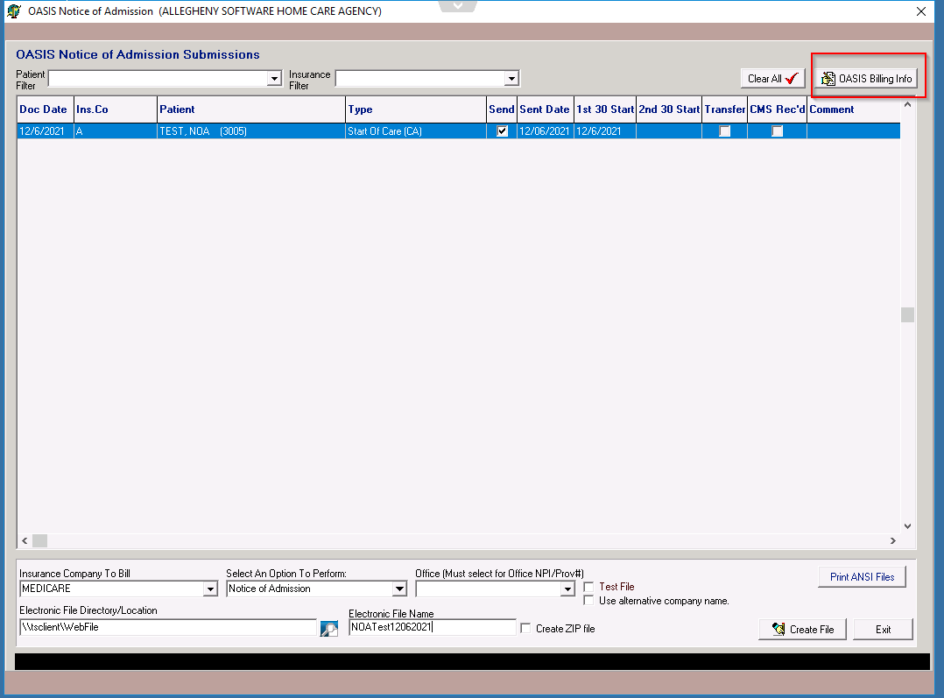
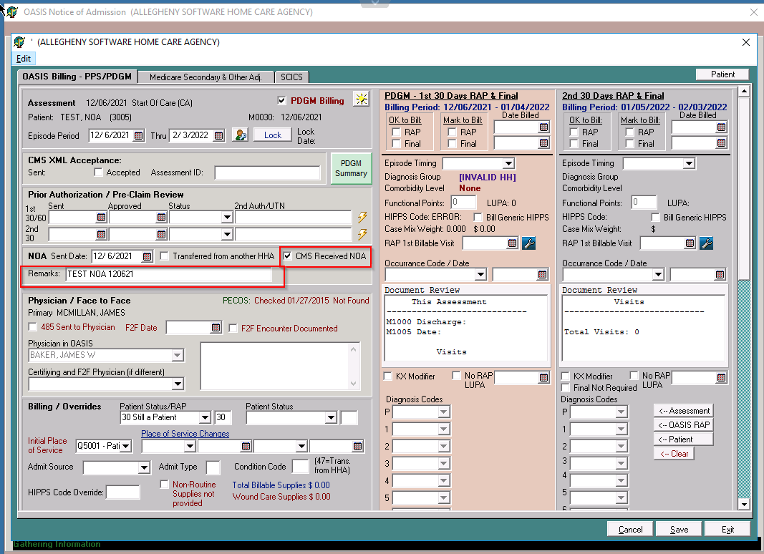
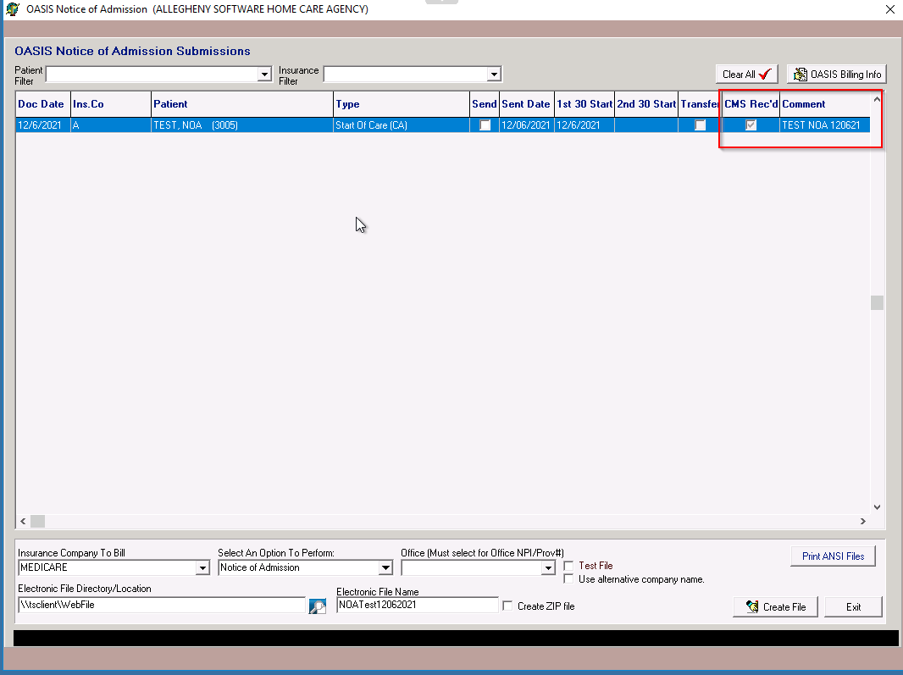

Additional Information:
- All patients receiving HH services in 2021 whose services will continue in 2022, agencies should submit a NOA with a one-time, artificial “admission” date corresponding with the “From” date of the first period of continuing care in 2022. This artificial “admission” date will save on the patient Insurance Screen. The software will use that artificial admission date as the admission date, on all following claims until discharge. For all admissions after 1/1/2022, the admission date on the NOA will match the actual Admission date.
- The User MUST ensure a Primary Diagnosis is added prior to submitting NOA. This Primary diagnosis does not have to match the claims billed on the Final claim.
- How to add a Transfer from Another HHA:
  - If a patient is a transfer from another agency, the user would select the Transfer button. This will open the OASIS Billing information screen. This will allow the user to select the ‘Transferred from another HHA’ button within the NOA section. This will put Condition Code 47 on the NOA.
- How to Cancel NOA:
  - The user would follow the same process as generating the Notice of Admission, with exception of the Option to Perform would be change to ‘NOA Cancellation’.

