An enhancement has been made to the software to allow for documentation and tracking of Therapy (PTA/COTA) Supervision with Main Software version 7287 and Clinical 2991
  - On the Main Patient Demographics Screen, users will now see tracking for not only the HHA but also for PTA and COTA.
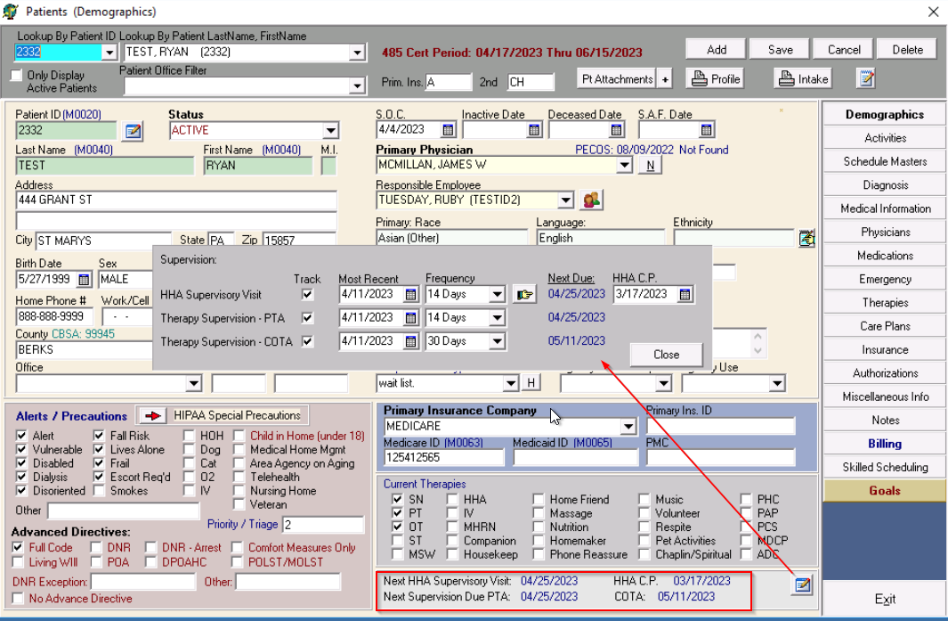
- Tracking frequency can be set for 7, 14, 30, 60 or 90 days. Once entering the frequency, the ‘Next Due’ date is updated using

- Supervisory Visit notifications will be displayed upon login to Clinical Software for employees listed on the ‘Therapies’ screen for each discipline.
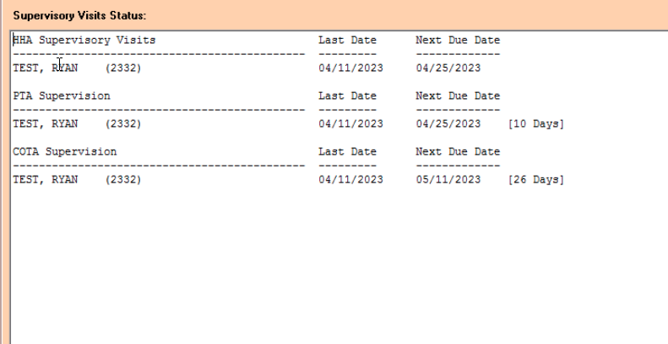
- For Documentation of Therapy Supervision, there is now a ‘Therapy Supervision’ tab within the Narrative screen on the Physical Therapy and Occupation Therapy Assessments. There is NOT a separate note that needs to be added to the visits for Therapy Supervision.
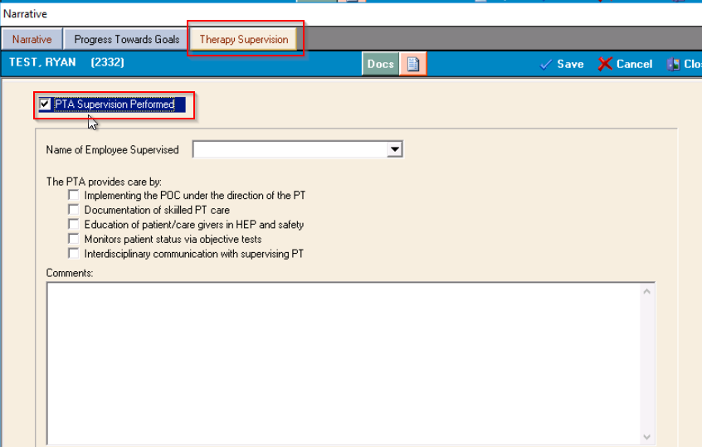

- Within Main Software the Supervision Status Report has been updated to include all supervision tracking as needed.
