New feature within Clinical Software---Recertification Due Tracking

A new feature has been added to the HHC3000 Clinical Software. Clinicians, listed as the Responsible Employee, can now be notified of when their patients current certification period ends when they login into the Clinical software.
The Agency can set up their own paraments of how many days in advance the Responsible Employee is notified or can choose to use the software default of 14 days. This can be set per patient to accommodate different insurance regulations.
Within Main Software on the Patient Demographics screen there is a new field next to the Responsible Employee labeled “POC Expires”.
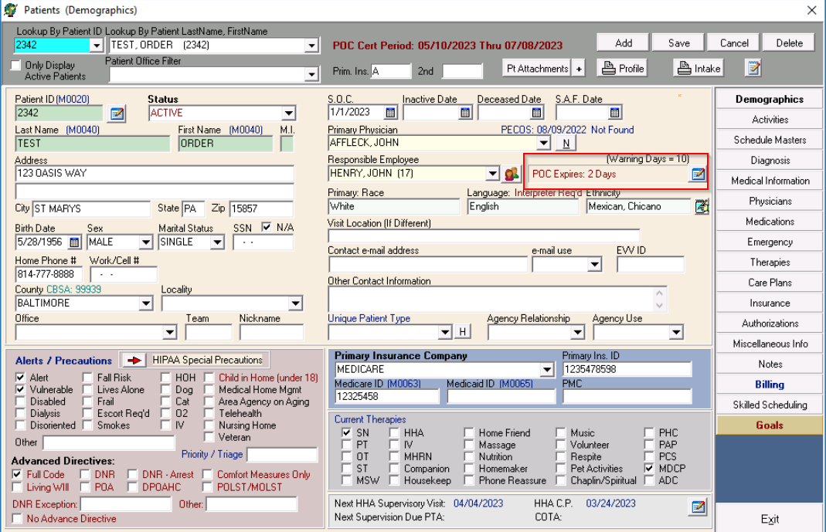
The Agency can change the “warning days” default setting of 14 days from 0-99 day if they choose.

When the Clinician, who is also listed as the Responsible Employee, logs into the Clinical software they will see a screen that reminds them of any patient that has a certification period ending in that set time frame or that is overdue.
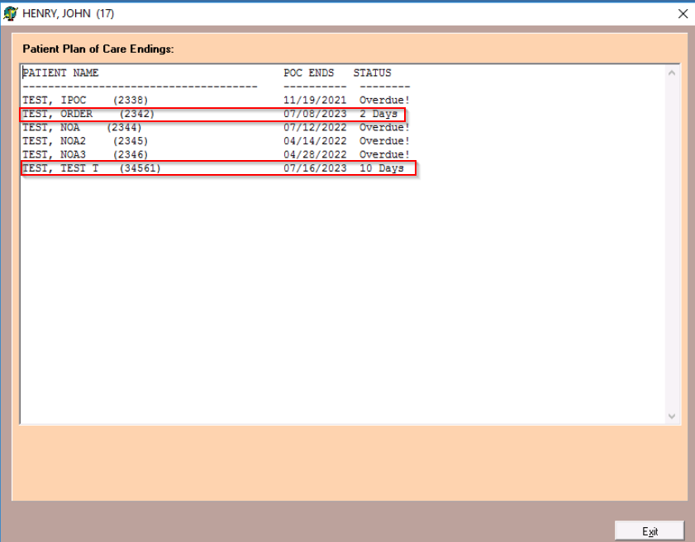
If an Agency does not wish to use this feature, there will be an override to turn this feature off.

If you have any questions, please contact Allegheny Software Support at 1-800-527-7213 or via email at support@alleghenysoftware.com

Allegheny Software Support Team

