CMS has added three new telehealth codes from home health services. These codes are required on claims starting on July 1, 2023.
G0320: Home health services furnished using synchronous telemedicine rendered via a real-time two-way audio and video telecommunications system.
G0321: Home health services furnished using synchronous telemedicine rendered via telephone or other real-time interactive audio-only telecommunications system.
G0322: The collection of physiologic data digitally stored and/or transmitted by the patient to the home health agency (for example, remote patient monitoring)

This is available within the HHC 3000 software.
The user would setup a Service Billing Rate and select the Unique Visit Type of ‘Telehealth’
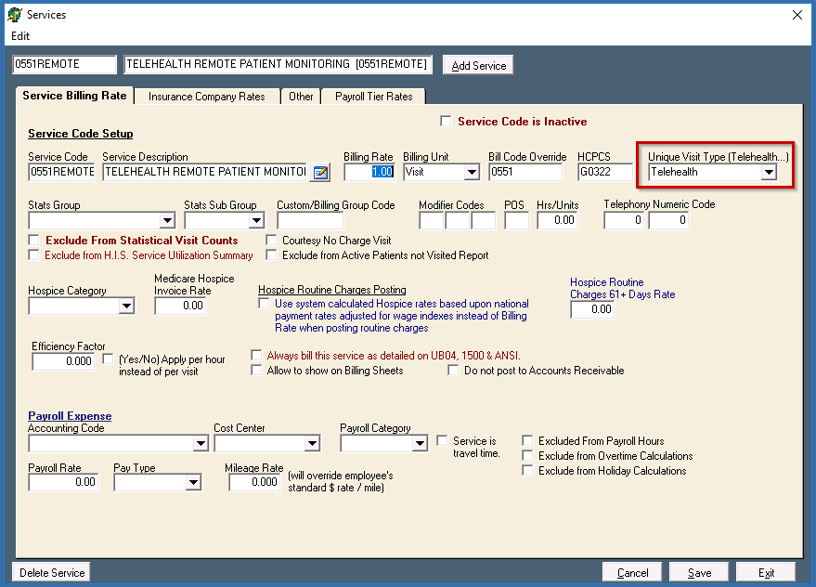
Code G0322:
If the agency is providing the G0322 service, the user would go into the patient’s chart and select the Therapies button on the right-hand column. Then they would select the ‘Telehealth’ tab at the top of the screen. Daily monitoring can be added by selecting the ‘Add’ button under the Telehealth Daily Monitoring Periods on the left-hand side of the page.
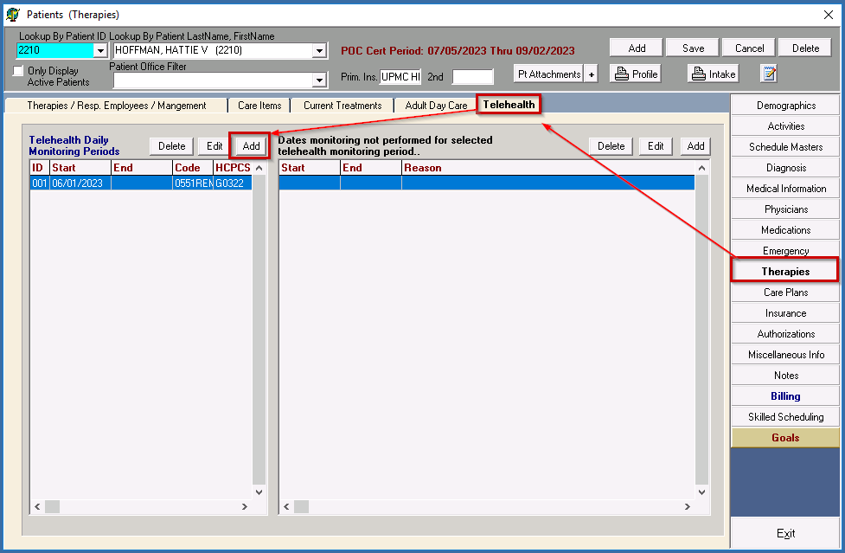
This will create a secondary window that will allow the user to add the start date of the collection period. User is able to add a start date and leave the end date blank and collection period is continuing. User would select the service and associated HCPCS code and select Post.
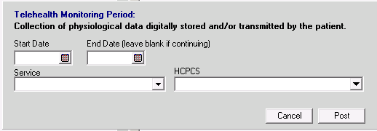
If the patient did not perform their telehealth due to hospitalization or another reason, the user would add in dates that telehealth monitoring was not performed for the selected telehealth monitoring period. This is on the right side of the screen. User would select the ‘Add’ Button. Add in the Start-End date that the telehealth was not performed along with the reason, and Post.
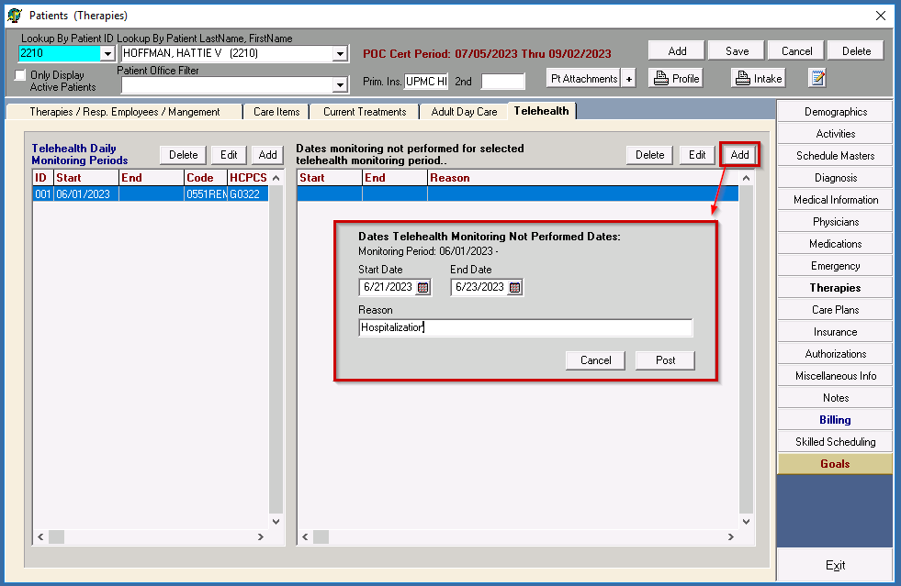
This will allow Billing to pull the telehealth information to the claim, but the dates of 6.21.2023 to 6.23.2023 will be excluded.

Codes G0320 or G0321:
The user would go into the patient’s chart and select the Activities button on the right-hand column. Then they would select ‘Add’ button, and select the ‘Telehealth Visit’
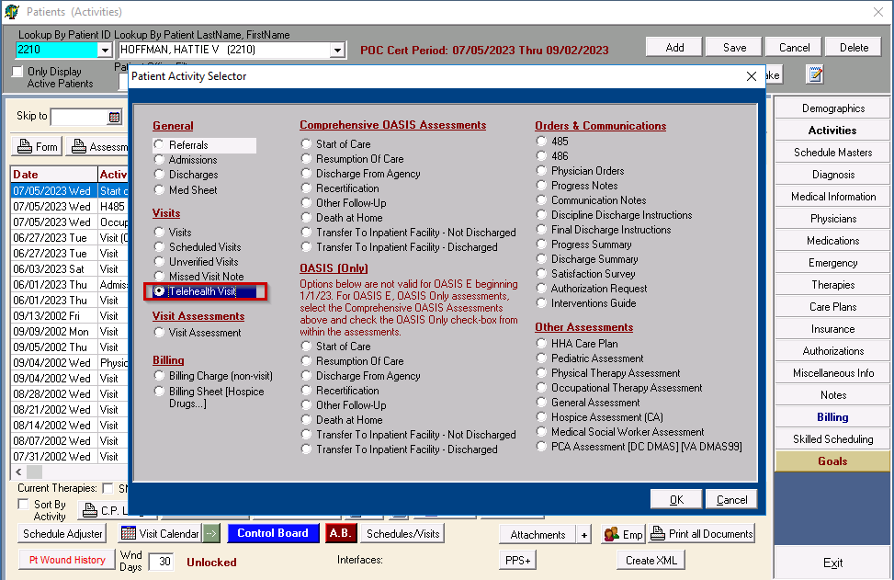
Select ‘OK’. This will bring up a Telehealth Visit form. This will allow the user to enter the date/employee/insurance company/Revenue/Service/Start/End time and HCPCS code. This would not be used for collection of physiological data digitally stored and/or transmitted by the patient (Example: Remote Patient Monitoring)
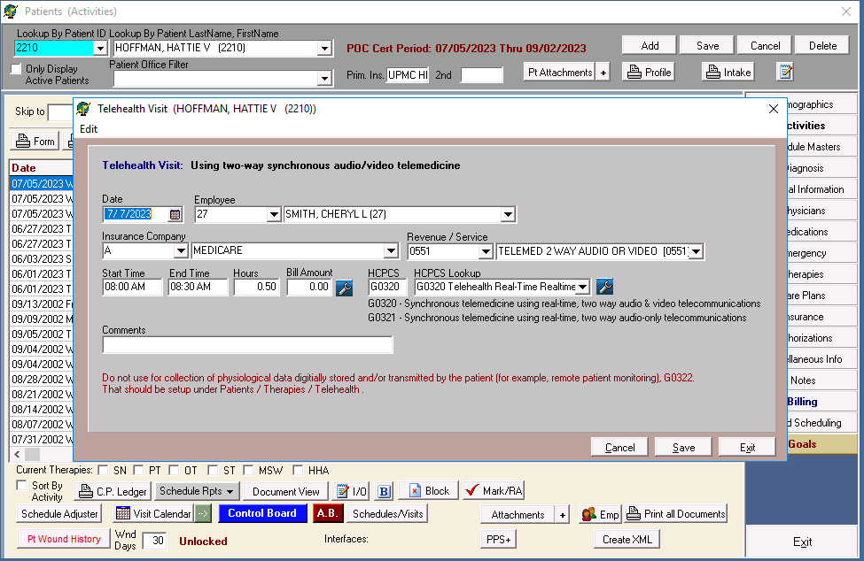

All telehealth items entered into the software should pull for Medicare billing. If telehealth items are needed on other Insurance billing, there is an override that will need to be added under Insurance Setup: “Include Telehealth Billing”
