The icon for adding an Incident Report has been added to the Clinical Screen in the right lower section of the Patient Grid screen. (See screen shot below)
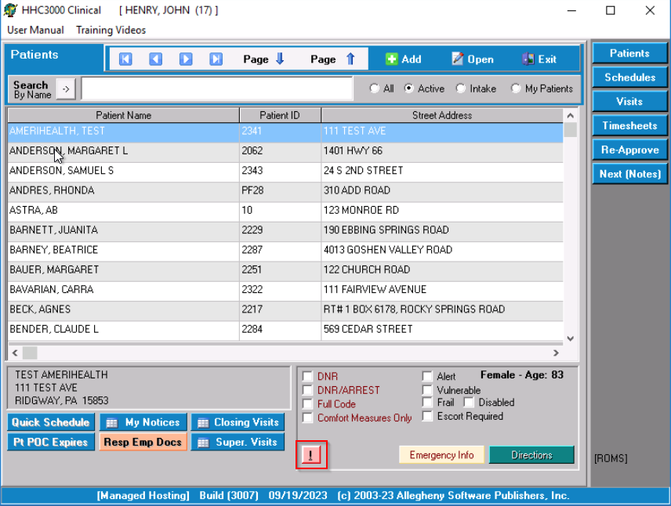
- The user will select the patient from the grid and then click the .
- A confirmation window is displayed. The user must confirm that they want to add an incident report for this patient and acknowledge that they will not be able to reopen or delete the report once it has been closed. (Main users will be able to edit/delete the report as needed)
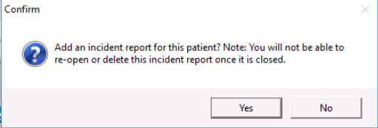
- Once the Clinical user confirms, the Incident report displays for completion.
- When the Clinical User tries to “Close” the document, a second confirmation window appears. The user must acknowledge that once the document is closed in the Clinical software that no additional changes will be able to be made. (Updates/Edits can be made within the Main software only.)
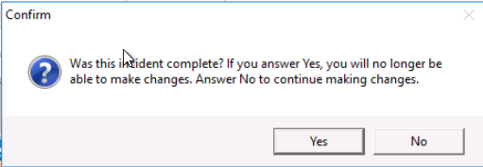
- After confirmation, the document will display as usual within the Main Software from the Control Board.

