Patient Signature and Employee Electronic Approval
A new enhancement has been added to the Main software with update 7372 dated 10/20/2023 that will allow Main Software users to easily view visits that have been signed by the Patient within Clinical Software and/or have the electronic approval applied by the Clinician.
To view this feature, Main Software user will open the Control Board and select the Pt Activity>Visits.
On the Visits tabs the screen can be filtered by Patient, Employee or Date if desired.
There is a new button option called Signatures. When selected, 2 new columns will display: Patient Signature and Approved.
The grid displays the date and time of the Patient Signature and the date and time of the most recent Employee Electronic Approval. If the grid is blank, then the information is missing from that visit.
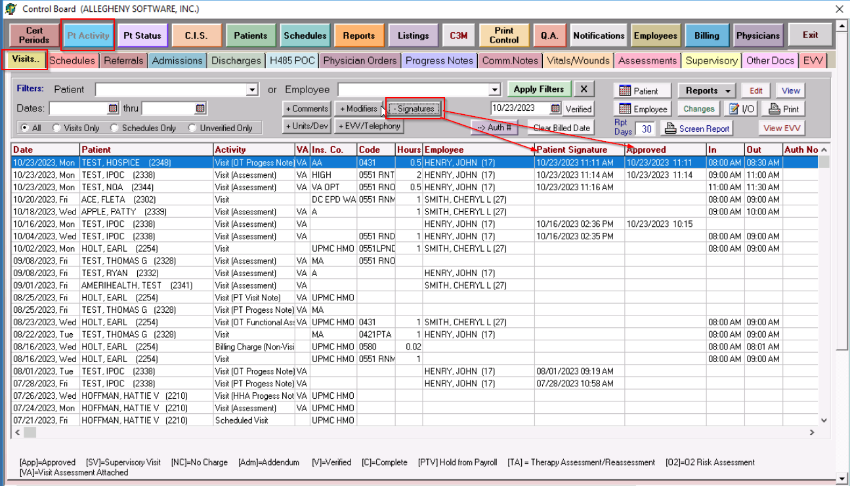
If the user does not wish to see those columns, they can be hidden by selecting the Signatures button again.

