Enhancements to Medications
With Main Software update 7455 (02/02/2024) and Clinical Software update 3022 (02/02/2024) there have been enhancements added to the Patient Medications tab
Within Main and Clinical Software: Patient Medications
- Active Medication Filter: The ability to filter the grid for “Active Meds Only” checkbox has been added. This allows the user to filter out any medication with a Stop date from the grid.
Main
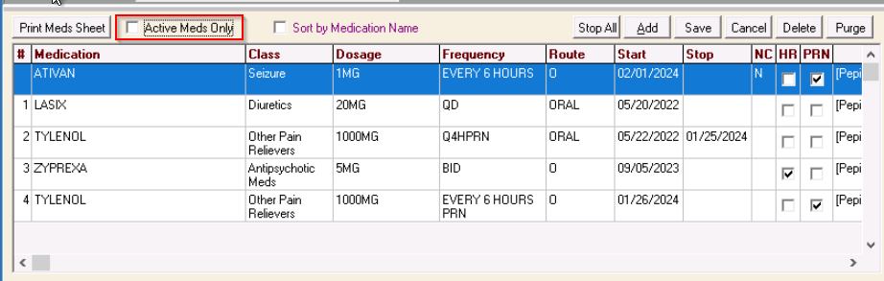
Clinical
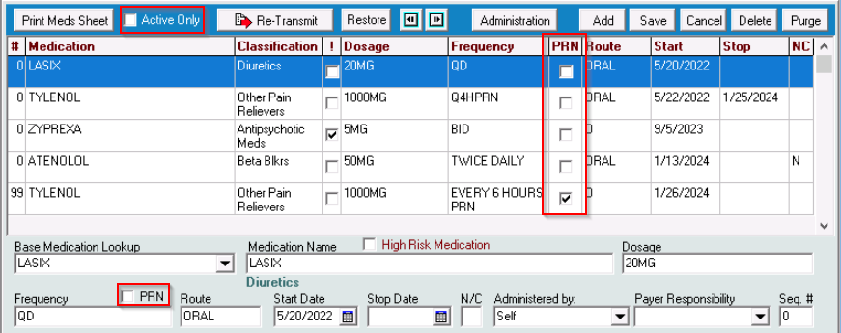
- PRN Medication: The software now has a PRN checkbox located above the medication frequency text field. If desired, clinicians can use this checkbox to define the ordered frequency for a medication is “prn”.
A new column has been added to the medication grid to display that the medication is ordered prn (if the clinician has selected the prn checkbox)
When printing a Medication Sheet, the ability to list all PRN medications last is now an option. This function works if the user has selected the PRN checkbox for those medications.
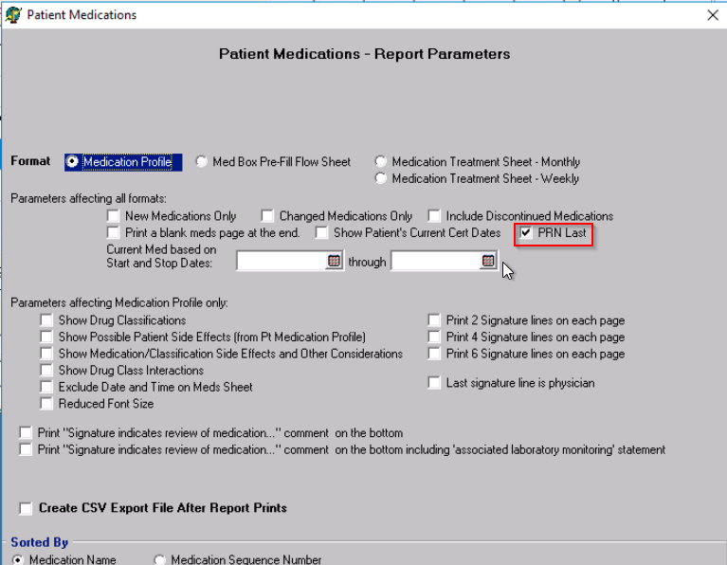

MAR ADMINISTRATION RECORD----Clinical Software Only
The Clinical Software now has the ability for clinicians to document the administration of a medication within the electronic medical record.
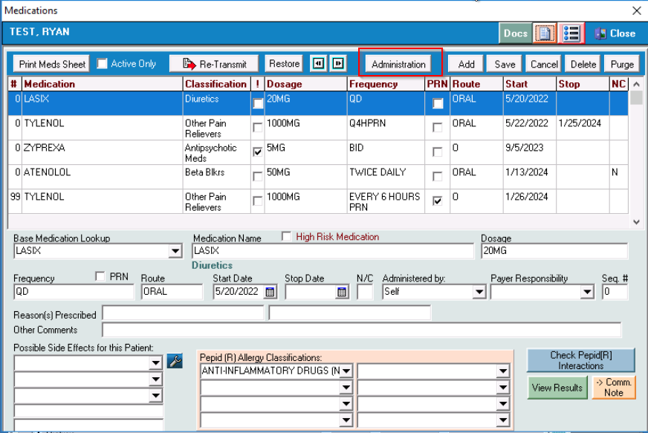
A new button has been added to the medication grid labeled ADMINISTRATION. This button opens another screen for documentation.
The clinician will select the ADD button at the top half of the screen. This open an area at the bottom of the screen.
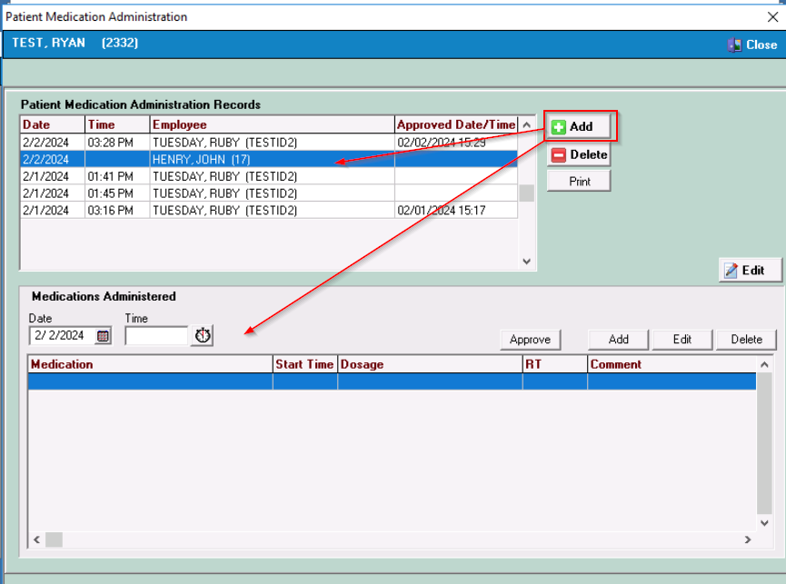
The clinician will enter the TIME the documentation is being completed by either using the stopwatch icon or manually enter the time.
After adding the time, the clinician will select the ADD button on the lower section of the screen. This will open a secondary window where the clinician can select which medication was administered from the drop-down menu and then select the TAB button.
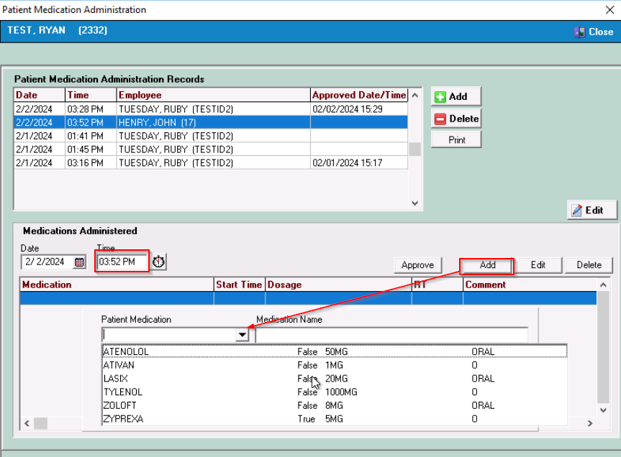
This will populate the secondary window with the ordered dosage and route. The user will enter the TIME the selected medication was administered and a comment if desired. The clinician will then CLOSE the window.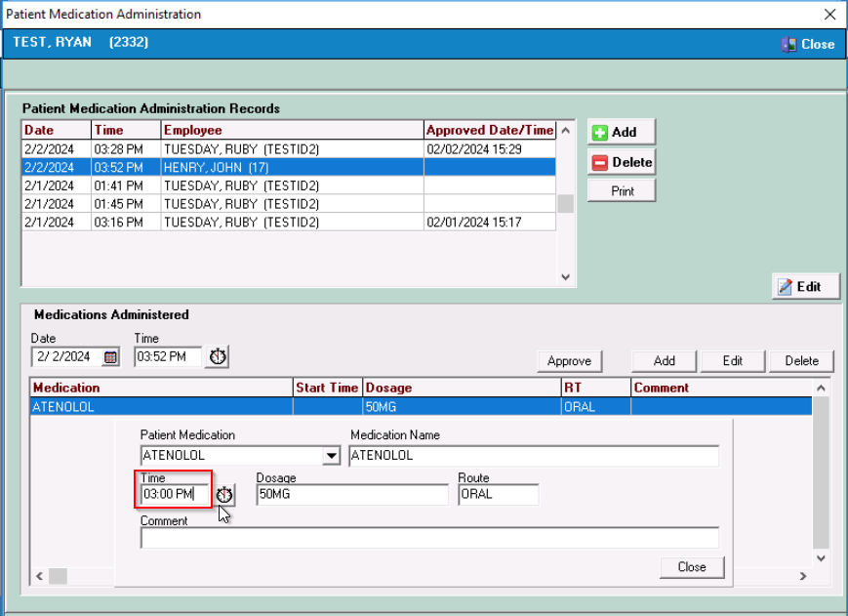
The medication, time administered, dosage, route and any comment entered will display on the grid on the lower section of the screen. The user can follow the same steps to document any additional medications that were given. All documented medication administrations will display at the bottom of the screen.
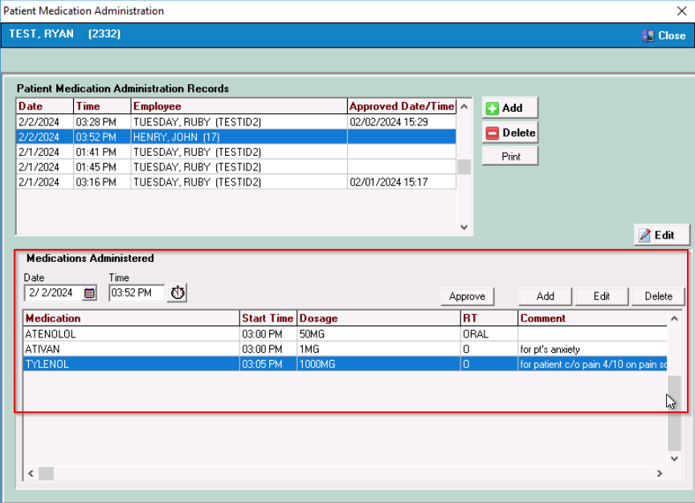
After the clinician is done documenting the medications administered, they will select the APPROVAL button to apply their electronic approval which will display on the top grid.
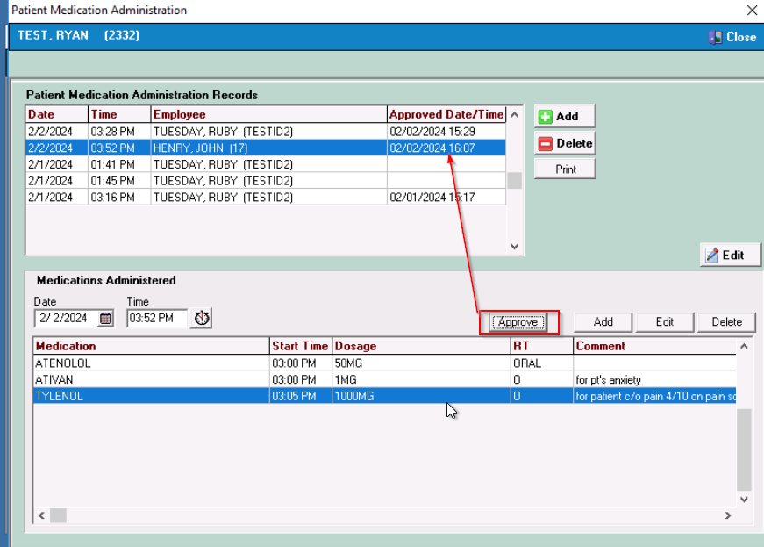
The clinician can review what medications were administered by selecting a line from the Patient Medication Administration Records at the top of the screen. NOTE—A clinician can only EDIT their own Medication Administration Record.
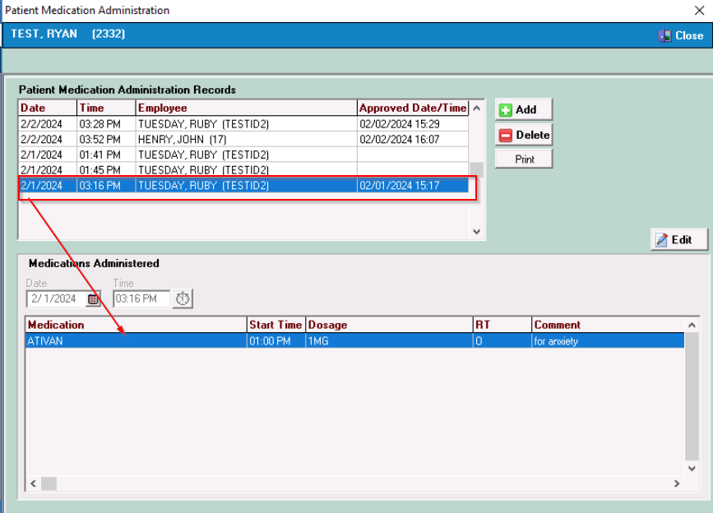
Printing the Medication Administration Record: The individual Medication Administration Records can be printed by selecting the PRINT button on this screen. This currently prints each record separately.
** A report that will print all administered medication during a time frame is still being developed and will be ready soon. **

Please contact Allegheny Software Support for any questions.

