A new feature has been added to the History tab within the OASIS SOC and General Assessments.
This enhancement can be accessed by clicking the icon located next to the Significant Past Health/Medical History and Past Surgical History.
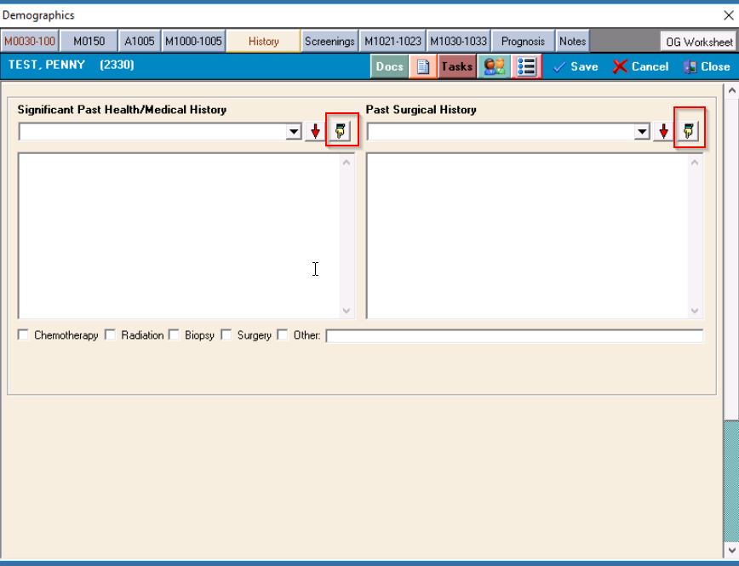
Once the user selects the icon, a secondary window will display where the user selects the appropriate items then selects the POST option
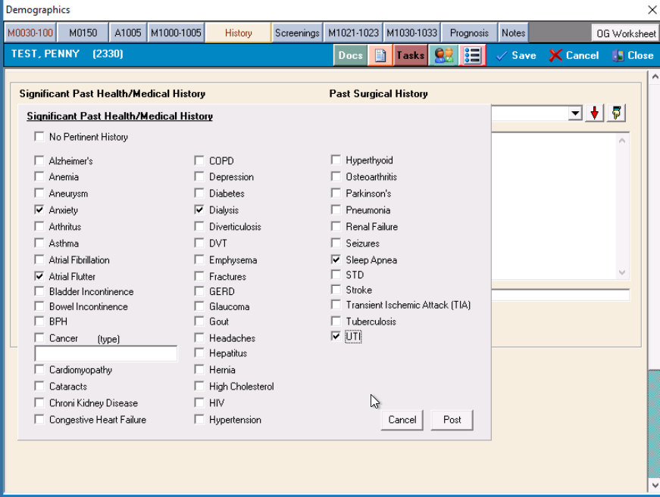
The items selected from within the secondary window will display within the text box for the appropriate text field for either Past Medical History or Past Surgical History.
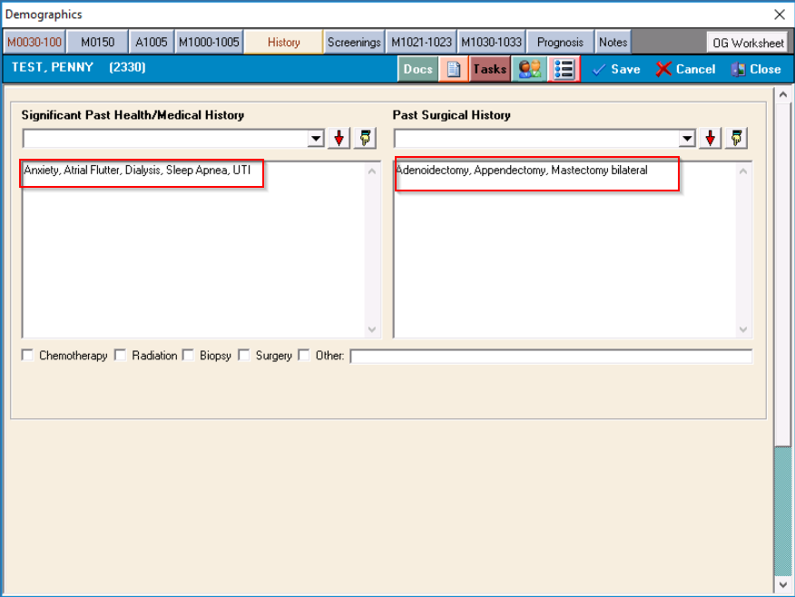

Users can still use the Drop-down items, Phrases, and/or free text fields as before.

If you have any questions, please contact Allegheny Software.

