History of SENT, RESENT, and RETURNED dates on PHYSICIAN ORDERS
with Main software version 7625 (01/21/2025)

A new feature has been added to the Main Software to be able to view the history of when a user has marked that a PHYSICIAN ORDER has been sent, resent, and returned.
When a user enters or updates a date that a PHYSICIAN ORDER has been SENT, RESENT, and/or RETURNED, the software records the date, time and user that made the change.
This feature is available in the Print Control >Physician Orders, Control Board>Pt Activity>Physician Orders, and Physicians>Orders. Currently this feature is only available with PHYSICIAN ORDER documents.
Users will continue to follow the current process for marking a PHYSICIAN ORDER as sent, resent or returned. If a user needs to see the history of when and who updated this information in the past it can be seen from within the VIEW tab within the following screens:
PRINT CONTROL
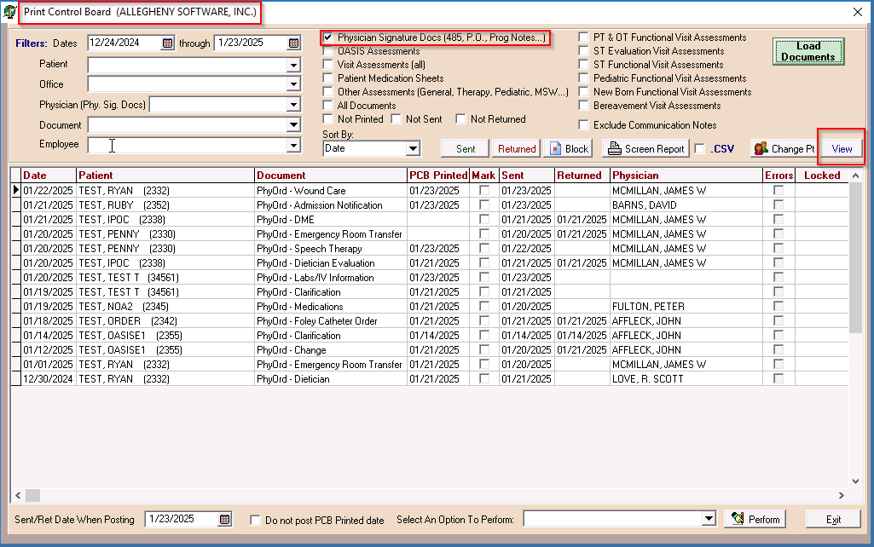

CONTROL BOARD
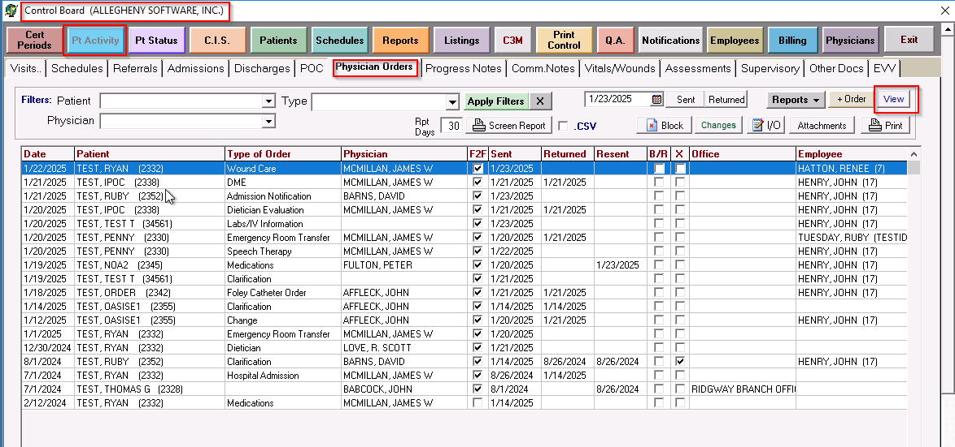
PHYSICIANS
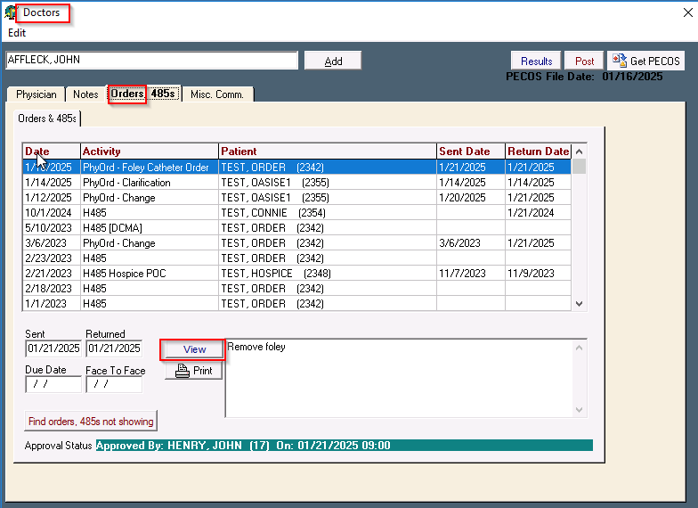
Within the VIEW screen there is a Sent/Resent button. When a user selects that button, a PDF will generate. It will display dates entered for Sent, Resent and Returned. Whenever any of those dates are entered or updated, the information is recorded and will display in the history.
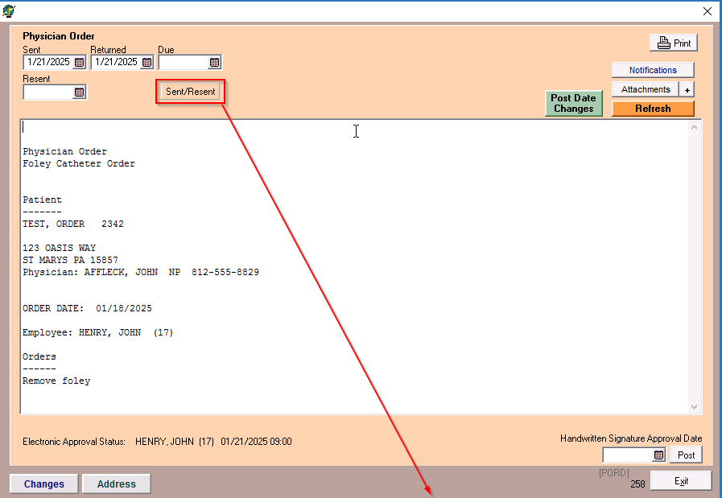
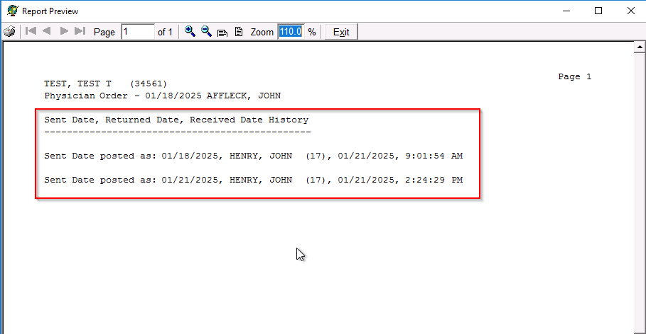
***Currently this feature is only available for PHYSICIAN ORDER documents***

