A new enhancement has been added to the software. This enhancement will alert a second user when another user is currently editing a Visit record. This currently only applies to routine visit documentation and not comprehensive assessments.
The second user will see an alert when they try to edit a routine visit record that someone else is currently working on. The edit lock should remove itself when the first user exits the record.
This warning will appear in both the Main and Clinical software.
Main:
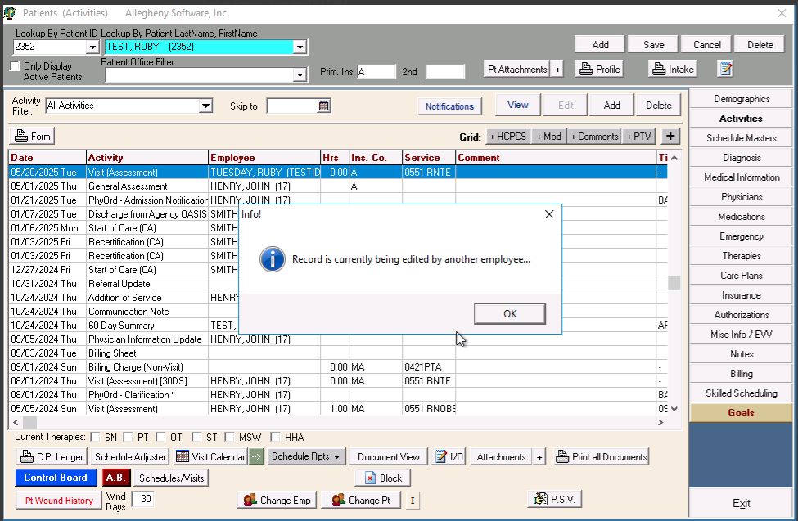
Clinical:
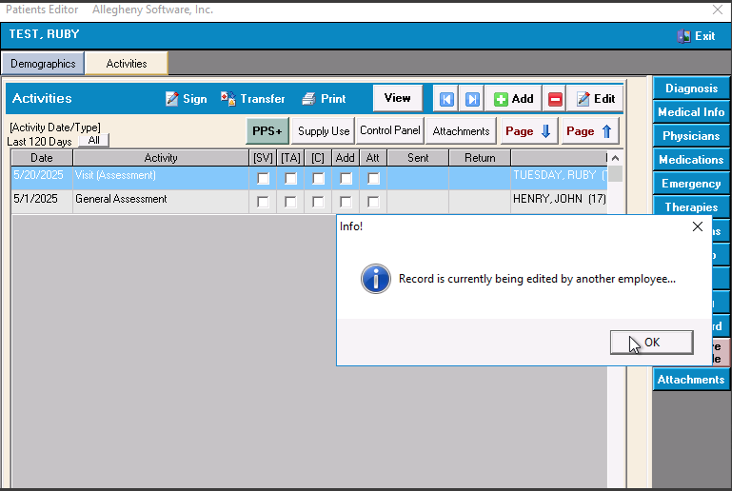
If the recorded needs to be unlocked manually, a Main user may unlock the record via the Activities Screen>VIEW BUTTON. If the record is locked, there will be a ‘lock’ symbol at the bottom of the VIEW screen. Users can click that lock symbol and unlock the record.
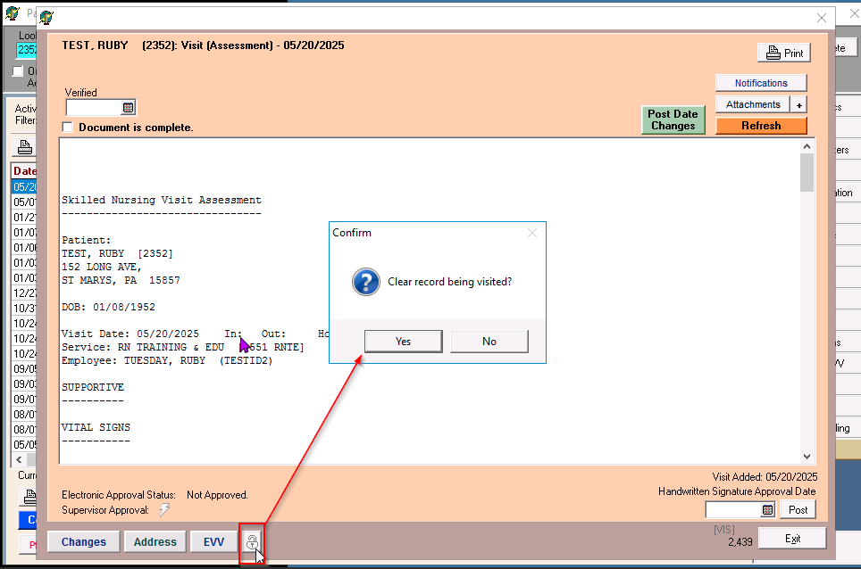
This new feature is included in the Main software version 7707 (05/21/2025) and Clinical 3070 (05/22/2025) for our CLOUD users. This enhancement is not applicable for server-based software.

